**ANUBHAV MISHRA**

**ASSIGNMENT-2**

**BHARATI VIDYAPEETH’s COLLEGE OF ENGINEERING , NEW DELHI**

1. Create a post request from another JS file/application and hit the /transaction on Localhost:3000

AJAX SCRIPT to HIT Transaction Message on port 3001

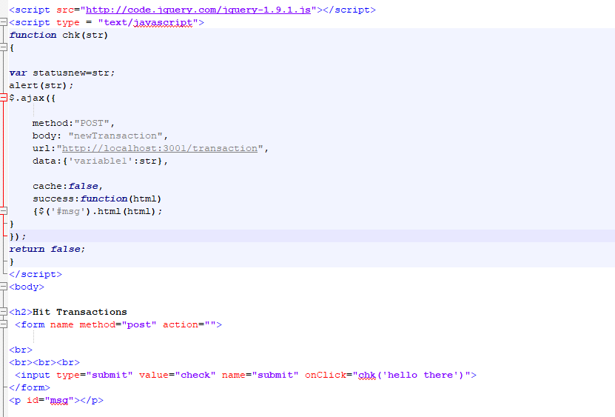

OUTPUT on Browser

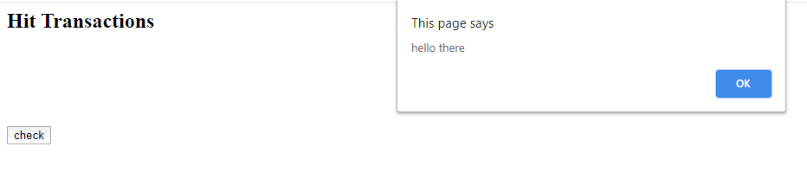

OUTPUT on port 3001 reflected after mining on port 3001

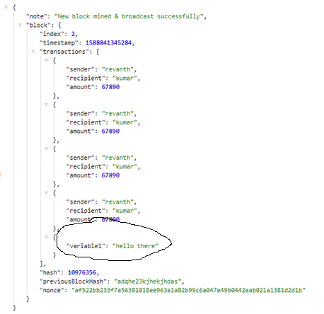

1. **Learn and implement sample code on request promises**

The simplified HTTP request client 'request' with Promise support

This module is installed via npm:

npm install --save request

npm install --save request-promise

request is defined as a peer-dependency and thus has to be installed separately.

var rp **=** require('request-promise');

Since request-promise wraps around request everything that works with request also works with request-promise

Sample Code using request_promise

// As a Request user you would write:

var request = require('request');

request('http://google.com', function (err, response, body) {

if (err) {

handleError({ error: err, response: response, ... });

} else if (!(/^2/.test('' + response.statusCode))) { // Status Codes other than 2xx

handleError({ error: body, response: response, ... });

} else {

process(body);

}

});

// As a Request-Promise user you can now write the equivalent code:

var rp = require('request-promise');

rp('http://google.com')

.then(process, handleError);